**Assignment Title**

Misleading Statistics in Healthcare - Covid-19 Cases

**Assignment Objectives**

Locate an example of a misleading visual that uses one or more of the mechanisms for misleading that Cairo outlines in his book chapter: (1) Hiding relevant data; (2) Displaying too much data and obscuring reality; (3) Distorting data through visual forms.

**Chart**

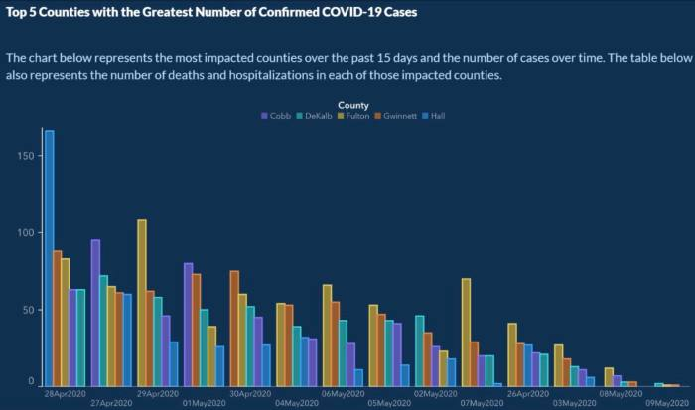

**Source**: <https://www.datapine.com/blog/misleading-statistics-and-data/>

**Caption**

The chart was originally published by the Georgia Department of Public Health. This diagram shows the number of Covid-19 cases spanning across 14 days in the second quarter of 2020 after the inception of the pandemic. The controversy surrounding this has been widely reported by Vox, Business Insider, Dailymail etc. The data comes from 5 sources - namely Cobb, DeKalb, Fulton, Gwinnett, Hall.

**Briefly describe the context for the visual by addressing the following questions:**

1. What is the source of the visual? (e.g., URL or bibliographic citation)  
     
   Main Source:<https://www.datapine.com/blog/misleading-statistics-and-data/> I Googled “misleading data” and the site was in the top 5. The visual seems to have amalgamated data from five sources, namely Cobb, DeKalb, Fulton, Gwinnett, Hall. There is no information on the sampling methodology or the locations where the samples were taken from. Other sources of the infographic include Vox, Business Insider and Dailymail.
2. Who is the intended audience (i.e., decoders)? How do you know this?  
     
   I believe the intended audience would be everyone affected directly or indirectly by the Covid-19 pandemic. Given that the data was released in 2020, and the articles commenting on the controversy came out during May 2020 suggests that this incident occured during the heart of the pandemic. The data could be part of a periodic update on the Covid-19 situation, which would mean that the publishers intended for those affected by the pandemic to view it.
3. Identify the specific component(s) of the visual that is/are misleading  
     
   (a) The horizontal axis is not arranged chronologically, and it seems that the intention was to show the audience a false decreasing trend in the data.

(b) The arrangement of data from the aforementioned five sources are not arranged in a consistent fashion, which means the authors were intentionally creating an image of a decreasing trend to mislead the readers, similar to point (a).   
  
(c) The vertical axis is not labeled accurately. Is it in thousands, ten thousands or millions? It is unclear. And yet this is the least concerning detail in our analysis, because at least they started the axis label from zero.

1. For each part(s) of the visualization that is/are misleading, identify the mechanism that is used: hiding relevant data to highlight what benefits us; displaying too much data to obscure reality; using graphic forms in inappropriate ways (distorting the data)  
     
    In this case, the primary mechanism for misleading the audience was using graphic forms in inappropriate ways (data distortion). More specifically in the inappropriate distortion of data through inconsistent ordering and improper (in this case, a lack of) labeling of the axes, primarily the horizontal axis. The article also published the actual chart if the misleading mechanisms were to be removed, showing a sparse distribution without any clear trend, with a peak in May. (Source:<https://www.datapine.com/blog/misleading-statistics-and-data/>) I presume that the reason for publishing the original misleading graph was for click-bait, to lure readers who are optimistic regarding the decline of Covid-19.

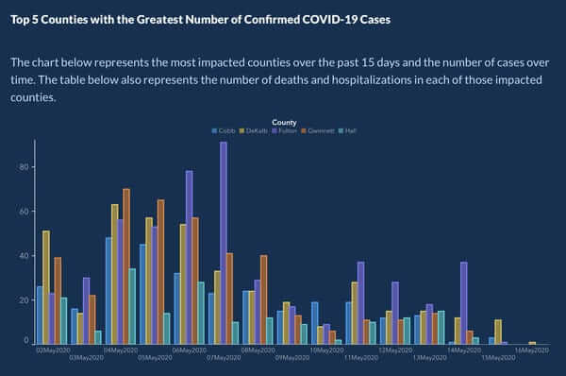

1. Explain how the mechanisms are used to mislead

The mechanisms created an image of a falsely declining trend in Covid-19 cases. This misled the decoders into believing falsely that the Covid-19 cases are declining over time, leading to false optimism to the detriment of the decoders.

Optional: Describe any additional issues you found with visual that did not fall under Cairo's three misleading mechanisms.

There was insufficient data. I feel that there should be a longer timeframe for the data representation, like a longitudinal study.